A FAMILY CURRICULUM

ROOTED IN SEASON
Read the Bible with your children through the church year. Start with short stories, a song, and a prayer. Follow the story from Genesis to Revelation, then add longer readings and discussion as your children are ready.
“One generation shall commend your works to another, and shall declare your mighty acts.”
Psalm 145:4
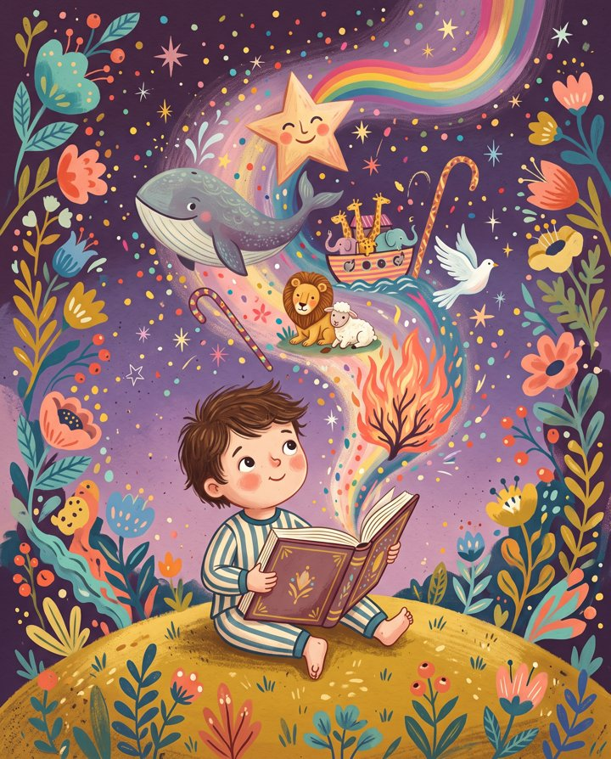

Foundations

WHY THIS SHAPE
Deuteronomy 6:6 to 7 tells parents to speak about God's words during daily life. Choose a time you can keep, such as bedtime, a meal, or a walk. Read aloud and talk together.
Return to familiar stories. Pictures give children details to point to while they listen. A small study of preschoolers found differences in brain-network activity across audio, illustrated, and animated stories. It supports using illustrated read-alouds, but does not establish one reading method for every child.
James Fowler described early faith in terms of trust, images, stories, and the example of trusted adults. His framework informs the age bands here. Use those bands to plan what you read and discuss. They are guides, not fixed stages that every child reaches on schedule.
Sofia Cavalletti's Catechesis of the Good Shepherd and Jerome Berryman's Godly Play inform the use of simple story materials and open questions. Read the passage, let your child handle a relevant prop, and ask what they notice or wonder. Give them time to answer.
A note on Dr. Allen Tennison. The older bands draw on his teaching about reading difficult biblical passages in context and discussing work and calling. The source list below identifies the talks used in this plan.

The goal

THE WHOLE STORY
Follow the Bible's main story from creation to the new creation each year. The younger bands use selected stories. Older bands work toward reading the full text. Alabaster Co.'s A Beautiful Year with Jesus, a 365-day devotional, is one reference for regular reading across a year.
The nine chapters below organize the readings around the church calendar. Advent introduces creation and God's promises. Christmas focuses on Jesus' birth. The following weeks cover Exodus and the kings. Lent and Holy Week follow Jesus' ministry and death. Easter covers his resurrection and the early church. After Pentecost, read about the church, the letters, and Revelation. Include Psalms and wisdom readings throughout the year.

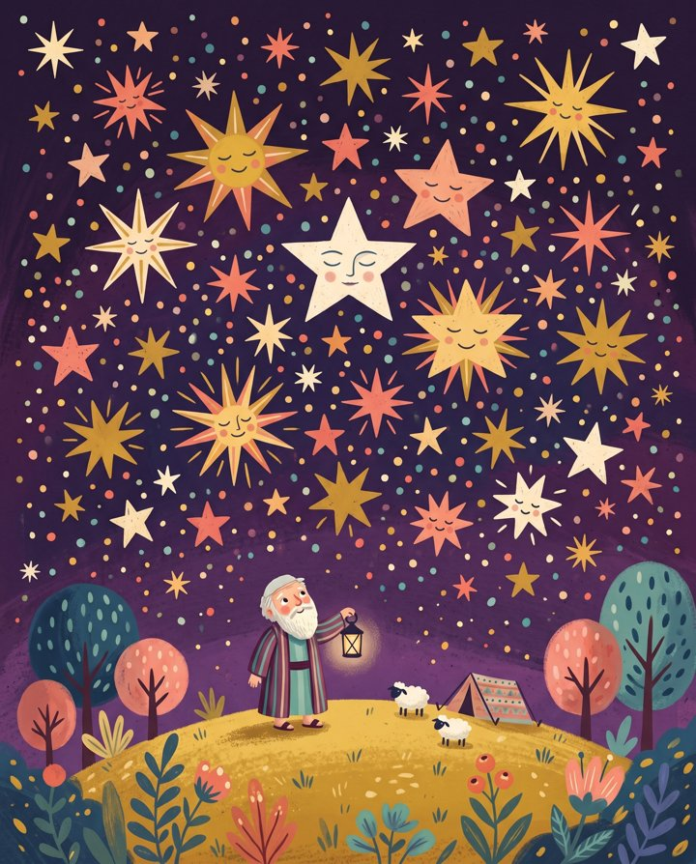 | Chapter one  ADVENT  4 WEEKS BEFORE CHRISTMAS  “The people walking in darkness have seen a great light.” Isaiah 9:2  Covers: Creation, the Fall, the first promise of a rescuer, Abraham, and the prophets. Read these stories across the four weeks before Christmas.
 | Chapter two  CHRISTMASTIDE  DEC 25 to JAN 5  “For unto you is born this day a Savior.” Luke 2:11  Covers: Jesus' birth in Luke 1 to 2 and Matthew 1 to 2. Return to the nativity readings throughout the twelve days.
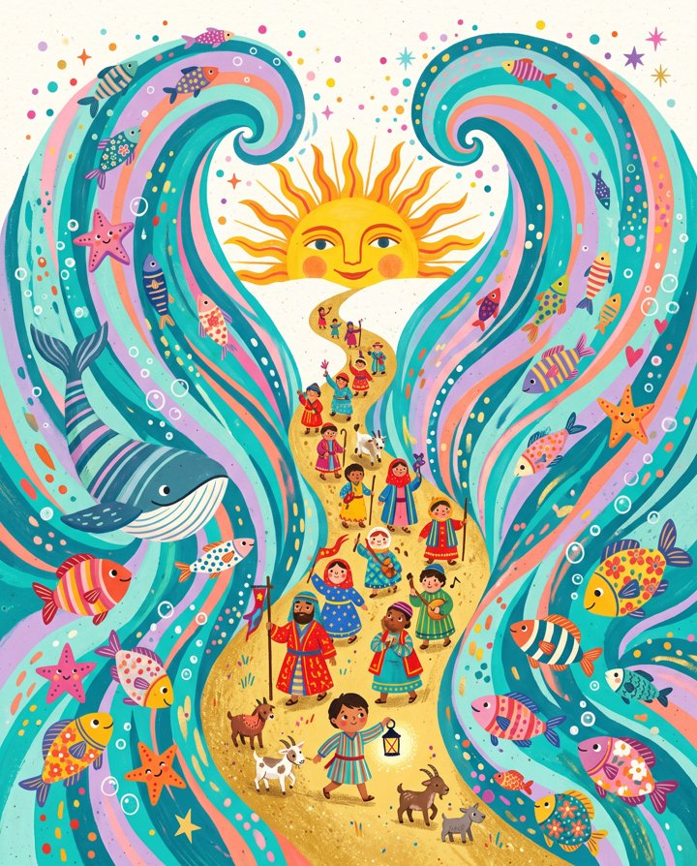 | Chapter three  EPIPHANY  JAN 6 → THE WEEKS BEFORE LENT  “The LORD will fight for you.” Exodus 14:14  Covers: Moses, the plagues, the crossing of the sea, and the covenant at Sinai. Trace how God rescues Israel in Exodus.
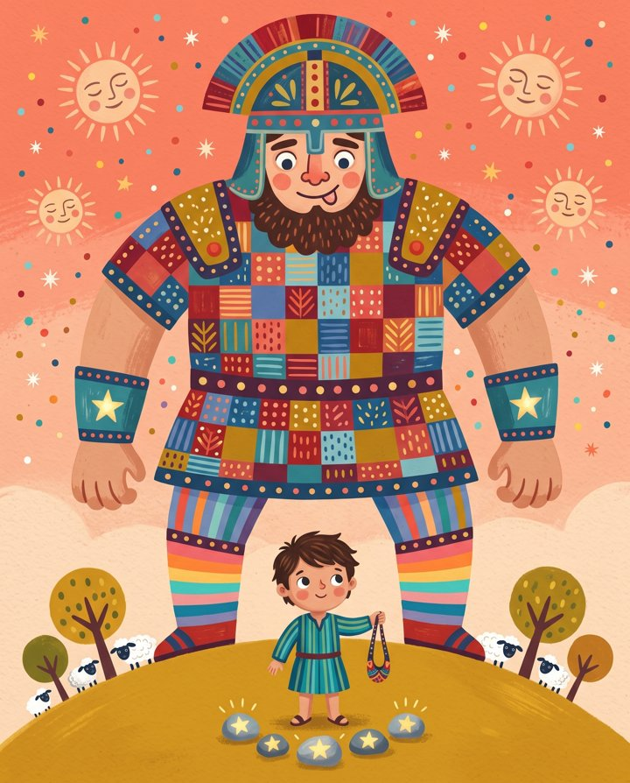 | Chapter four  THE KINGS  THE RUN-UP TO LENT  “The LORD looks on the heart.” 1 Samuel 16:7  Covers: Judges, Ruth, Saul, David, and Solomon. Discuss the kings' choices and failures, and the promise of a king who will rule justly.
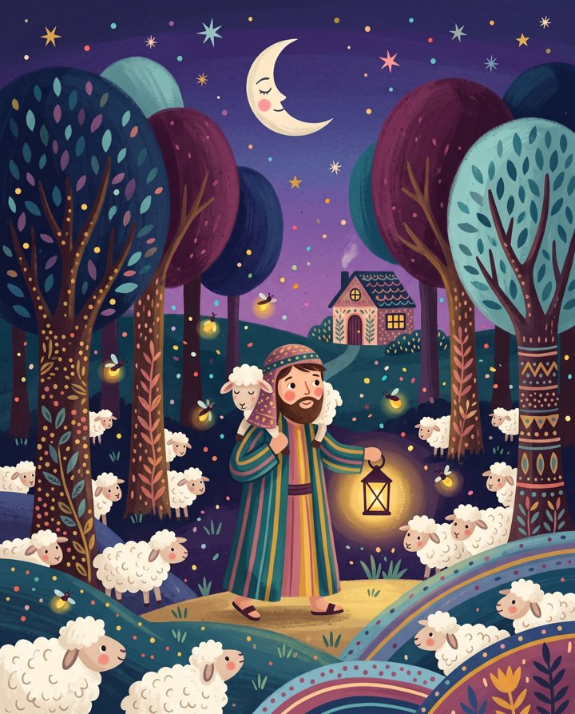 | Chapter five  LENT  ASH WEDNESDAY → PALM SUNDAY  “He was pierced for our transgressions.” Isaiah 53:5  Covers: Jesus' parables, miracles, and teaching as he travels toward Jerusalem. Read the related prophetic passages alongside the Gospel accounts.
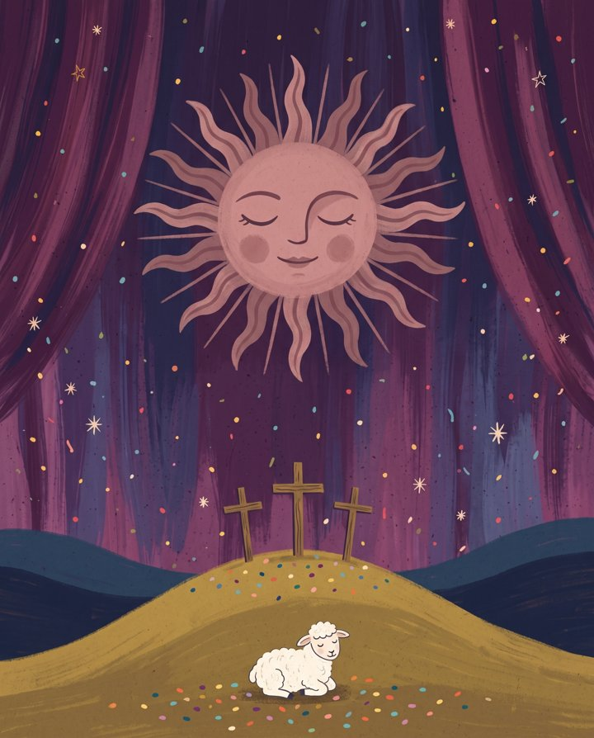 | Chapter six  HOLY WEEK  PALM SUNDAY → HOLY SATURDAY  “Even death on a cross.” Philippians 2:8  Covers: The events of Jesus' final week across the four Gospels. Follow them day by day, with short readings and time for questions.
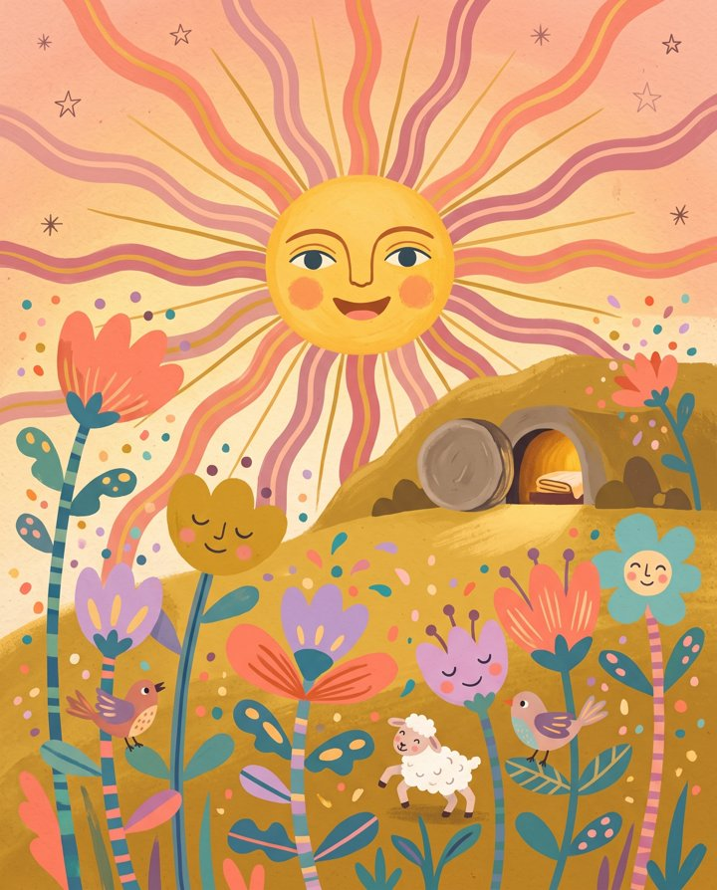 | Chapter seven  EASTERTIDE  EASTER → PENTECOST, FIFTY DAYS  “He is not here; he has risen!” Luke 24:6  Covers: Jesus' resurrection appearances and Acts 1 to 12. Read how his followers respond and how the early church begins.
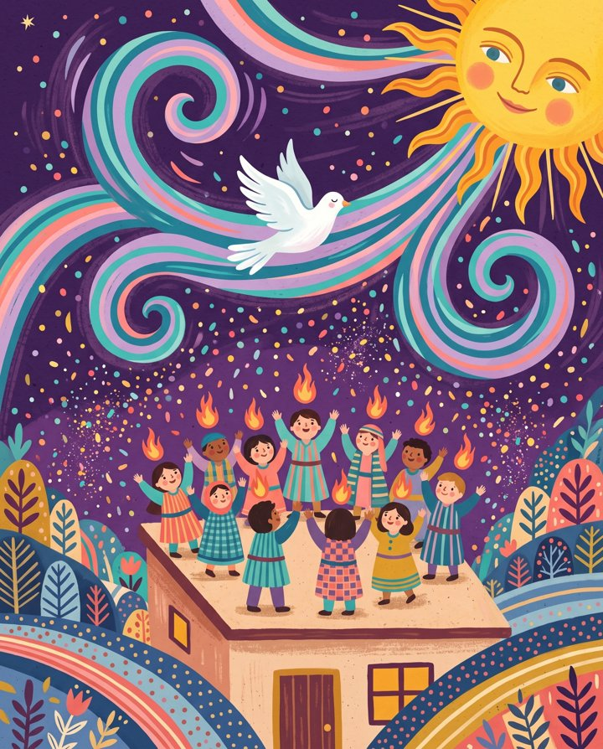 | Chapter eight  PENTECOST  PENTECOST → LATE NOVEMBER  “I will pour out my Spirit.” Acts 2:17  Covers: Acts 13 to 28 and the letters from Romans through Jude. Continue the Psalms and wisdom readings. Finish with Revelation before Advent begins again.
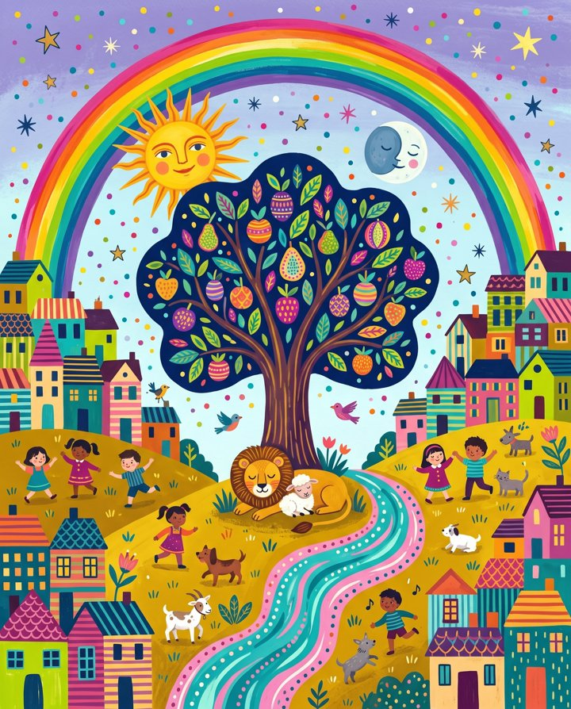 | Chapter nine  ALL THINGS NEW  LATE NOVEMBER, JUST BEFORE ADVENT  “Behold, I am making all things new.” Revelation 21:5  Finish the year with God's promise to make all things new. Read about the end of tears, death, and night. The next season begins with Advent.

The framework

GROWING IN FAITH
Keep the chapter sequence. Adjust the reading and each child's part in it. They may listen, point, act out a story, read with you, or read independently. The detailed Year One plan starts in Band 01. Choose another band if its activities fit your child better.
00  Birth to 18 months | FOWLER: UNDIFFERENTIATED FAITH  Sing, read aloud, and use a short bedtime blessing. Hold and respond to your baby. There are no lessons to complete in this band.
01  18 months to 3 years | INTUITIVE-PROJECTIVE BEGINS YEAR ONE BEGINS HERE  Read roughly 12 to 16 key stories from a picture-book Bible, such as The Jesus Storybook Bible. Repeat them across the seasons. The Year One page lists the books, weekly readings, songs, and refrains for this band.
02  3 to 6 years | CAVALLETTI'S “SWEET SPOT”  Read three to five stories per chapter from a fuller storybook Bible. Offer felt figures or simple props for retelling. Ask an open question, such as "I wonder what they felt," and listen to the response.
03  6 to 9 years | BRIDGE INTO CONCRETE REASONING  Read short passages from a simplified Bible translation alongside the storybook. Follow the same chapters. Invite your child to read a refrain or a few lines aloud.
04  9 to 13 years | STRUCTURED DOCTRINE BECOMES USABLE  Use a one-year chronological reading plan organized around the seasons. Read one of the 52 questions in The New City Catechism for Kids each week. Discuss difficult passages in context, using Tennison's teaching as a reference.
05  13+ years | FORMAL REASONING, FAITH BECOMING THEIR OWN  Your teenager manages a one-year plan to read the full Bible, including every letter and wisdom book. Discuss genre, historical context, questions about faith, and work and calling. Tennison's "Four Greats" teaching is a reference for that last topic.

BAND 01 · 18 MONTHS to 3 YEARS

YEAR ONE
Use one story, refrain, song, and activity each week. The plan includes eleven weeks to establish a routine, followed by fifty-two weeks through the church year. Read the same story during the week and give your child a part they can manage.
Sept 13, 2026 to Nov 21, 2027 · 63 weeks · 5 minutes a night · Selected Bible stories

The nightly shape

HOW TO USE IT
Choose a regular time to read with your children. Siblings can share the song, story, and prayer. An older child can read or retell while a younger child listens or holds a prop. Follow the four steps below in the same order. Aim for five minutes. On a difficult night, shorten the reading and keep the prayer.
1  Sing  Sing this week's song once. Let your child join a word or chorus. | 2  Story  Read this week's story. Repeat the same pages through Saturday. | 3  Say  Say this week's line, then pause for your child to respond. | 4  Pray  Say the four-line prayer below. Turn off the lamp.

The bedtime prayer
Thank you, God, for this good day.
Thank you for Jesus, who shows the way.
Keep us close the whole night through.
Good night, God. We love you.

Repeat the week's story.
Read the same story through the week. Point to familiar details and let your child anticipate what happens next. Adjust the length to their attention.
Use three-week blocks in Ordinary Time.
In week one, read the story. In week two, use the story prop as you read. In week three, invite your child to retell it through words, gestures, or play. Help when they ask.
Repeat the week's refrain.
"God keeps his promise." "Jesus is the Good Shepherd." "He is risen." Say the week's line after the story, then pause so your child can join in. Use the same wording throughout the week.
Use a story prop.
Choose an object that connects to the story, such as a flameless candle, lamb figure, or blue scarf. Let your child use it while you read.
Notice retelling outside the session.
Notice when your child acts out a story or uses its words outside reading time. If this happens regularly, try a Band 02 story or an open question. Adjust based on their response.
Adjust a missed or difficult session.
If you miss a week, continue with the current week. There is no catch-up work. If your child keeps requesting Noah, reread it and keep the scheduled song. Shorten or stop a session when needed.

What to read from

THE SHELF
The four books below have different uses. Start with the main storybook, then check the others for the readings you need. You do not need to buy all four at once.
 | MAIN READ-ALOUD  The Big Picture Story Bible  David R. Helm, illustrated by Gail Schoonmaker · Crossway  This illustrated storybook presents the Bible as a connected account of God's people, place, and rule. Use it as the main read-aloud this year. Check the contents for each scheduled story before the week begins. Read a short section at a time. Let your child look at the picture before turning the page. If a scheduled story is absent, use another book on this shelf that contains it and keep the week's refrain.
  1
 | SHORT READINGS AND OUTINGS  The Beginner's Bible for Little Ones  Zonderkidz · board book  A board book with short retellings and pages a young child can handle. Keep it in the reading basket or take it on outings. Use it for brief readings between the main sessions.
  2
 | ADDITIONAL READ-ALOUD STORIES  Read-Aloud Bible Stories, Volume 1  Ella K. Lindvall, illustrated by H. Kent Puckett · Moody  Short sentences and large pictures suit reading aloud. Volume 1 includes Zacchaeus, a man who could not see, Jesus and the children, the storm, and a man who returned to thank Jesus. Use it for the matching weeks. Jonah and the man who could not walk are not in this volume.
  3
 | MAIN READ-ALOUD FOR BAND 02  The Jesus Storybook Bible  Sally Lloyd-Jones, illustrated by Jago · Zonderkidz  Forty-four stories connect the biblical account to Jesus. Use this book in Bands 02 and later as your child is ready for longer readings. Preview the pages before Advent to understand the book's use of "the Rescuer."
  4

Songs used in the plan

THE SONGBOOK
Sing the week's song together. Use a verse, chorus, or hummed melody your child can follow. The table groups the songs used in this plan.
SONG | WHEN IT COMES UP | WHY THIS ONE
Jesus Loves Me | Any week without a listed song | Sing together or use it as a Band 00 lullaby.
He's Got the Whole World in His Hands | Creation weeks | Add hand motions and invite your child to copy them.
Rise and Shine (Arky Arky) · Who Built the Ark? | Noah | Count the animals and stomp together on "arky arky."
Jesus Loves the Little Children | Jesus and the children | Sing after reading about Jesus welcoming the children.
O Come, O Come Emmanuel | Advent (first verse, humming is fine) | Sing or hum the first verse during Advent. Your child can listen or join in.
Away in a Manger · Silent Night · Joy to the World | Late Advent and Christmastide | Sing these carols with the related nativity stories.
God Is So Good · Deep and Wide | Exodus, the storm, Daniel | Use short phrases and arm motions. Repeat the parts your child joins.
Only a Boy Named David · Zacchaeus Was a Wee Little Man | The Kings; Lent week 4 | Sing the account after reading it. Point out the matching events.
This Little Light of Mine | Pentecost, Paul, any Ordinary week | Hold up a finger as the light and move it with the song.
Christ the Lord Is Risen Today (the alleluias) · This Is the Day · Give Thanks | Eastertide; the Psalms weeks | Sing the verses. Invite your child to join the alleluia or "this is the day" response.

Two optional albums. Slugs & Bugs: Sing the Bible by Randall Goodgame uses scripture in songs. Rain for Roots: Big Stories for Little Ones, with Sandra McCracken, Flo Paris, and other musicians, retells Bible stories in song. Use either for listening outside the nightly reading.

The shopping list, by season

THE BASKET
Keep the supplies in a basket near your reading chair. Check what you already have, then gather the remaining items as each season approaches. The printable checklist groups them by date.
Before Nov 29 · Advent 1  The core  ☐ A basket, a lamp your child can switch, and the chair  Choose a regular place to sit and read in week one.  ☐ The Big Picture Story Bible  See the shelf above.  ☐ A toddler-proof nativity set  Choose age-appropriate figures your child can move. Check the age label on sets such as Fisher-Price Little People "Christmas Story" or Melissa & Doug wooden nativity.  ☐ Advent wreath with four flameless LED candles  Use four battery-operated candles with secure battery compartments. Traditional colors are three purple or blue and one pink. Other colors also work.  ☐ A small lamb figure  Use an age-appropriate felt, wooden, or plush lamb for the Good Shepherd story from prelude week six. |  | By Jan 10 · Epiphany  Exodus & The Kings  ☐ A blue scarf or length of blue fabric  Use it as Moses' river and the sea in the Exodus and Jonah stories. One yard is enough.  ☐ A small jar and five smooth stones  Find the stones together. An adult should handle and store small stones out of a toddler's reach. Keep the jar closed between sessions.  ☐ A paper crown  Make it from gold card. An adult should cut and fasten it.

By Feb 10 · Ash Wednesday  Lent  ☐ A purple cloth  Put a purple napkin or runner on the table on Ash Wednesday. Leave it until Easter morning.  ☐ The Lent path printable + 40 dot stickers  Print the path below. Add one sticker each night from Ash Wednesday to Holy Saturday, excluding Sundays.  ☐ A small pot, soil, and fast seeds  Plant wheatgrass or beans during Lent week two. Water them and check for growth together. |  | By Mar 21 · Palm Sunday  Holy Week, Easter, Pentecost  ☐ A palm branch or one big leaf  Prepare it during the week before Palm Sunday.  ☐ The Holy Week strip printable  Print the strip below. Uncover one picture each day. Keep the empty-tomb sun covered until Easter.  ☐ A red cloth  Put it on the table on Pentecost eve, May 15.  ☐ A pinwheel  Make or buy one and place it in the window on Pentecost.

Through the long green weeks · May to Nov
The back catalog
☐ Ark and animal figures
Use an age-appropriate toy ark or reuse the nativity animals for Noah and later retellings.
☐ A laundry basket, a toy boat, a stuffed lion
Use these for Jonah's boat, the storm, and Daniel's den. Check what you already have.
☐ A map or globe
Point to the places in Paul's travels during the scheduled weeks.
☐ Stationery and a stamp
Write a letter to a grandparent together during the Paul weeks.

Sept 13, 2026 → Nov 21, 2027

WEEK BY WEEK
Each row covers Sunday and the next six nights. Sing the listed song, read the story, say the refrain, and pray. Pause after the refrain for your child to respond. Complete the activity during the week. Check which book contains the story before Sunday. Use the eleven prelude weeks to establish the routine before Advent.
Prelude · Ordinary Time The long green weeks · Sep 13, 2026 to Nov 22, 2026 11 weeks
SUNDAY | THE STORY THIS WEEK | THE LINE TO SAY | THE SONG | THE RITUAL
Sep 13  prelude 1 | Set the reading time. Read a story your child already knows in the same place each night. | "Story time." (the same two words, every night) | Jesus Loves Me | Choose the chair, lamp, and basket.
Sep 20  prelude 2 | Creation. Point to the sun, sea, and animals and name them together. | "God made it. God made you." | He's Got the Whole World in His Hands | Put The Big Picture Story Bible in the basket. Read its Creation pages.
Sep 27  prelude 3 | Read Creation again. Let your child turn the pages. | "God made it. God made you." | He's Got the Whole World in His Hands | Add the four-line bedtime prayer from How to Use It. Repeat it each night.
Oct 4  prelude 4 | Noah. Read about the ark, the pairs of animals, and the rainbow. | "God keeps his promise." | Rise and Shine (Arky Arky) | Add a toy ark or animal figures to the basket.
Oct 11  prelude 5 | Read Noah again. Count the animals and find the rainbow. | "God keeps his promise." | Who Built the Ark? | Repeat the book and song. Notice any words your child joins.
Oct 18  prelude 6 | The Good Shepherd finds the lost sheep and carries it home. | "Jesus is the Good Shepherd." | Jesus Loves Me | Keep an age-appropriate lamb figure near the reading chair.
Oct 25  prelude 7 | Read the Good Shepherd again. | "Jesus is the Good Shepherd." | Jesus Loves Me | Hide the lamb, find it, and carry it home. Invite your child to take a turn.
Nov 1  prelude 8 | Jesus welcomes the children. | "Jesus loves the little children." | Jesus Loves the Little Children | Let your child hold the book or point to a child in the picture.
Nov 8  prelude 9 | Read about Jesus and the children again. | "Jesus loves the little children." | Jesus Loves the Little Children | Let your child choose Creation, Noah, the Good Shepherd, or Jesus and the children each night.
Nov 15  prelude 10 | Let your child choose a story from the basket. | "Story time." | This Little Light of Mine | Set out the unlit Advent wreath and empty nativity stable.
Nov 22  prelude 11 | Read a story from the basket. Show the empty manger and say, 'Jesus isn't here yet.' | "We are waiting for Jesus." | O Come, O Come Emmanuel (first verse, hummed) | Prepare the wreath and stable. Store the figures out of reach until their scheduled arrival.

Advent Waiting · Nov 29, 2026 to Dec 20, 2026 4 weeks
SUNDAY | THE STORY THIS WEEK | THE LINE TO SAY | THE SONG | THE RITUAL
Nov 29  wk 12 | Read Creation and the first promise that God would send a rescuer. | "We are waiting for Jesus." | O Come, O Come Emmanuel | Switch on candle 1 with your child. Add Mary's figure.
Dec 6  wk 13 | Abraham looks at the stars and hears God's promise. | "We are waiting for Jesus." | Father Abraham | Switch on candle 2. Add Joseph. Look at the stars together one evening.
Dec 13  wk 14 | The angel visits Mary and tells her a baby is coming. | "We are waiting for Jesus." | Away in a Manger | Switch on candle 3. Add the donkey and sheep. Leave the stable empty.
Dec 20  wk 15 | Read about the journey to Bethlehem and the place prepared for Jesus' birth. | "Almost. We are waiting for Jesus." | Silent Night | Switch on candle 4. Put the shepherds across the room and move them closer each night.

Christmastide He is here · Dec 27, 2026 to Jan 3, 2027 2 weeks
SUNDAY | THE STORY THIS WEEK | THE LINE TO SAY | THE SONG | THE RITUAL
Dec 27  wk 16 | Jesus is born. On Christmas morning, let your child place Jesus in the manger. | "Jesus is here!" | Joy to the World | Read the same nativity pages for twelve nights. Switch on all four flameless candles.
Jan 3  wk 17 | The wise men follow the star. Epiphany is Wed Jan 6. | "Jesus is here!" | We Three Kings (chorus) | Move the wise men across the room during the week. Bring them to the nativity on Wednesday.

Epiphany · Exodus God made a way · Jan 10, 2027 to Jan 24, 2027 3 weeks
SUNDAY | THE STORY THIS WEEK | THE LINE TO SAY | THE SONG | THE RITUAL
Jan 10  wk 18 | Read about baby Moses in the basket on the river. | "God made a way." | God Is So Good | Pack away the nativity together and say, 'until next year.' Use a blue scarf as the river.
Jan 17  wk 19 | Moses and the sea. God's people are trapped, and God makes a way through. | "God made a way." | God Is So Good | Arrange the blue scarf between two chairs. Walk through the sea together each night.
Jan 24  wk 20 | Read about the sea again. Invite your child to tell you what happens. | "God made a way." | Deep and Wide | Notice whether your child retells the story during play or conversation.

The Kings Small, and chosen · Jan 31, 2027 to Feb 7, 2027 2 weeks
SUNDAY | THE STORY THIS WEEK | THE LINE TO SAY | THE SONG | THE RITUAL
Jan 31  wk 21 | Read about David being chosen while he is a young shepherd. | "God looks at the heart." | Only a Boy Named David | Prepare a paper crown and a closed jar with five smooth stones. Keep small stones out of your child's reach.
Feb 7  wk 22 | Read David and the giant. Use a playful voice and avoid frightening details. | "God looks at the heart." | Only a Boy Named David | Put the purple cloth on the table on Ash Wednesday, Wed Feb 10.

Lent Walking toward the cross · Feb 14, 2027 to Mar 14, 2027 5 weeks
SUNDAY | THE STORY THIS WEEK | THE LINE TO SAY | THE SONG | THE RITUAL
Feb 14  wk 23 | Read about Jesus helping the man who could not walk. | "Jesus makes things right." | Jesus Loves Me | Put the Lent path on the wall. Add one sticker each day, excluding Sundays, until all forty stones are marked.
Feb 21  wk 24 | Jesus feeds the crowd with a boy's lunch. | "Jesus makes things right." | Praise Him, Praise Him | Plant a seed in a small pot. Water it and check its growth through Lent.
Feb 28  wk 25 | Jesus calms the storm. | "Jesus makes things right." | Deep and Wide | Continue the stone path and tend the seed. Repeat this week's reading.
Mar 7  wk 26 | Jesus sees Zacchaeus in the tree. | "Jesus makes things right." | Zacchaeus Was a Wee Little Man | Introduce the empty tomb page. Say, 'Jesus died, and then he was alive again.'
Mar 14  wk 27 | Return to the Good Shepherd finding the lost sheep. | "Jesus is the Good Shepherd." | The Lord Is My Shepherd (any simple setting) | Prepare a palm branch or large leaf for the following Sunday.

Holy Week One week, day by day · Mar 21, 2027 1 week
SUNDAY | THE STORY THIS WEEK | THE LINE TO SAY | THE SONG | THE RITUAL
Mar 21  wk 28 | Palm Sunday: wave the branch and say hosanna. Thursday: break bread at dinner. Friday: read briefly about Jesus' death. Saturday: sing without a story. | "Hosanna!" → "It's quiet tonight." | Hosanna (call and response) | Put the Holy Week strip on the fridge. Uncover one picture a day. Keep the empty-tomb sun covered until Sunday.

Eastertide Fifty days of alleluia · Mar 28, 2027 to May 9, 2027 7 weeks
SUNDAY | THE STORY THIS WEEK | THE LINE TO SAY | THE SONG | THE RITUAL
Mar 28  wk 29 | On Easter morning, read about the empty tomb and uncover the sun. | "He is risen!" Response: "He is risen indeed!" | Christ the Lord Is Risen Today (alleluias only) | Use the call-and-response at breakfast for fifty days. Invite your child to say the response.
Apr 4  wk 30 | Read about the empty tomb again and Mary in the garden. | "He is risen!" | Alleluia (any simple one) | Check the seed pot. If a shoot has appeared, point to it and say, 'alive.'
Apr 11  wk 31 | Jesus appears to his friends and says, 'Peace.' | "He is risen!" | This Is the Day | Return the familiar books to the basket. Keep the tomb page ready to read.
Apr 18  wk 32 | Jesus shares a fish breakfast with his friends on the beach. | "He is risen!" | I've Got the Joy, Joy, Joy | Prepare breakfast together once this week. Include bread and fish if practical.
Apr 25  wk 33 | Return to the beach breakfast. Invite your child to retell it. | "He is risen!" | I've Got the Joy, Joy, Joy | Let your child begin the Easter call-and-response. Take turns leading.
May 2  wk 34 | Jesus goes up to heaven. 'I am with you always.' Ascension Day is Thu May 6. | "Jesus is with me." | Jesus Loves Me | Look at the sky together after reading.
May 9  wk 35 | Jesus' friends wait and pray together. Pentecost is next Sunday. | "Jesus is with me." | God Is So Good | Make a pinwheel and put out the red cloth on Saturday night.

Pentecost Wind and fire · May 16, 2027 1 week
SUNDAY | THE STORY THIS WEEK | THE LINE TO SAY | THE SONG | THE RITUAL
May 16  wk 36 | Read about Pentecost, the wind, the flames, and people hearing the message in their own languages. | "God's Spirit is with me." | This Little Light of Mine | Put out the red cloth and pinwheel. Switch on a flameless candle at dinner.

Ordinary Time The long green weeks · May 23, 2027 to Nov 21, 2027 27 weeks
SUNDAY | THE STORY THIS WEEK | THE LINE TO SAY | THE SONG | THE RITUAL
May 23  wk 37 | Read about Jesus welcoming the children. | "Jesus loves the little children." | Jesus Loves the Little Children | Read outdoors once a week during summer if practical.
May 30  wk 38 | Read about Jesus and the children again. | "Jesus loves the little children." | Jesus Loves the Little Children | Continue the routine.
Jun 6  wk 39 | Invite your child to retell Jesus and the children. | "Jesus loves the little children." | Jesus Loves the Little Children | Continue the routine.
Jun 13  wk 40 | Read Jonah and the big fish. | "God is patient." | Who Did Swallow Jonah? | Use the blue scarf as the sea and a laundry basket as the boat.
Jun 20  wk 41 | Read Jonah again. | "God is patient." | Who Did Swallow Jonah? | Continue the routine.
Jun 27  wk 42 | Invite your child to retell Jonah. | "God is patient." | Who Did Swallow Jonah? | Continue the routine.
Jul 4  wk 43 | Read Daniel and the lions. | "God keeps me safe." | God Is So Good | Use stuffed lions and a blanket to make the den.
Jul 11  wk 44 | Read Daniel again. | "God keeps me safe." | God Is So Good | Continue the routine.
Jul 18  wk 45 | Invite your child to retell Daniel. | "God keeps me safe." | God Is So Good | Continue the routine.
Jul 25  wk 46 | Read Joseph and the colorful coat. | "God has a plan." | Father Abraham | Let your child wear a favorite bright shirt for the story.
Aug 1  wk 47 | Read Joseph again. Include the brothers' apology. | "God has a plan." | Father Abraham | Continue the routine.
Aug 8  wk 48 | Invite your child to retell Joseph. | "God has a plan." | Father Abraham | Continue the routine.
Aug 15  wk 49 | Return to the Good Shepherd and the lost sheep. | "Jesus is the Good Shepherd." | The Lord Is My Shepherd | Let your child hide the lamb. Find it together.
Aug 22  wk 50 | Read the lost sheep again. | "Jesus is the Good Shepherd." | The Lord Is My Shepherd | Continue the routine.
Aug 29  wk 51 | Invite your child to retell the lost sheep. | "Jesus is the Good Shepherd." | The Lord Is My Shepherd | Continue the routine.
Sep 5  wk 52 | Read about Jesus walking on water or calming the storm. | "Don't be afraid. Jesus is here." | Deep and Wide | Use a toy boat to act out the storm and calm during supervised bath time.
Sep 12  wk 53 | Read the storm again. | "Don't be afraid. Jesus is here." | Deep and Wide | Continue the routine.
Sep 19  wk 54 | Invite your child to retell the storm. | "Don't be afraid. Jesus is here." | Deep and Wide | Continue the routine.
Sep 26  wk 55 | Read about Paul's shipwreck and travels. | "God's family goes everywhere." | This Little Light of Mine | Point to places on a map or globe. Explain that Jesus' friends traveled to tell others about him.
Oct 3  wk 56 | Read about Paul writing letters to his friends. | "God's family goes everywhere." | This Little Light of Mine | Write a letter to a grandparent together.
Oct 10  wk 57 | Invite your child to retell Paul's story. | "God's family goes everywhere." | This Little Light of Mine | Continue the routine.
Oct 17  wk 58 | Psalms week. Sing 'The Lord is my shepherd' at bedtime. | "The Lord is my shepherd." | The Lord Is My Shepherd | Use the song and prayer without story pages.
Oct 24  wk 59 | Psalms week. Read or sing 'This is the day.' | "This is the day the Lord has made." | This Is the Day | Continue the routine.
Oct 31  wk 60 | Read the final stories about God making all things new, including the end of tears and the picture of the lion and lamb. | "God makes everything new." | Joy to the World (yes, in November) | Read the last pages, close the book, and say, 'and then we start again.'
Nov 7  wk 61 | Read All Things New again. Talk about bringing back the Advent candle. | "God makes everything new." | Joy to the World | Continue the routine.
Nov 14  wk 62 | Let your child choose a favorite story from the year. | "Story time." (whatever your child asks for) | Your child's favorite of the year | Write down the story they choose. Use the note when planning next year.
Nov 21  wk 63 | Psalms week. Read or sing 'Give thanks.' Thanksgiving is Thu Nov 25. Year One ends this week. Advent 1 is next Sunday, Nov 28. | "Thank you, God." | Give Thanks | At dinner, invite each person to name something they are thankful for. Bring out the wreath and empty stable on Saturday. Set aside fifteen minutes to review the plan.

Advent 1 of Year Two is Sunday, Nov 28, 2027. Repeat the four Advent stories and candle ritual. Invite your child to switch on the flameless candle.

Print on letter paper, tape to the wall

PRINTABLES
Print these six PDFs on letter-size paper. Let your child color or mark the seasonal trackers. Use one sheet per child or work on one together.
Advent star sky. Color one dated mark each night from Nov 29 to Christmas Eve. On the four Sundays, color the candle. Switch on the matching flameless candle. open the PDF
Lent stone path. Add one sticker to the forty-stone path each night from Ash Wednesday to Holy Saturday. Skip Sundays. open the PDF
Holy Week strip. Uncover one panel each day from Palm Sunday to Easter. Keep the final panel covered until Easter morning. open the PDF
The basket checklist. Check off the supplies as you gather them. The sheet groups items by the date you need them. open the PDF
The bedtime card. Keep this card near the reading chair. It lists the four steps, the prayer, and the year's refrains for any caregiver leading the session. open the PDF
The Tending Log. Record each annual review in the fourteen rows covering 2026 to 2040. open the PDF

ANNUAL PLANNING

TENDING IT
Review the coming year's readings on the Saturday before Advent. Use fifteen minutes to check each child's readiness, update the dates and story list, and prepare the supplies. Keep the same seasonal chapter sequence.
Every year, the Saturday before Advent 1 · next: Nov 27, 2027 · 15 minutes · dated through 2040

Tending Day, in order

THE FIFTEEN MINUTES
Set a fifteen-minute timer. Have the current plan and the Tending Log ready. Work through the five steps below.
0 to 3 min  read | Read this year's page, top to bottom.  Review which readings you completed, which your children requested again, and which activities needed changes. Note where the plan did not fit your family.
3 to 6 min  decide | Answer the two questions.  Has your child grown into a new band since last year? Review the observations below for each child. Does next year's plan actually reflect that? Decide whether to add readings, keep the current level, or adjust an activity. Siblings can use different bands.
6 to 10 min  retune | Update the year in front of you.  Keep the chapter sequence. Update the dates using the calendar below. Add stories if your child is ready, or keep the current list. Replace activities they have outgrown and retain useful ones. On paper, update the plan in the margins. To build a new web edition, copy both yearone-data.py and build_yearone.py. Set the copied builder to load the new data file and write a new output page. Update its dates, labels, and links. Run it and inspect the result.
10 to 13 min  the basket | Audit the basket.  Inspect the supplies for damage and check what the next band requires. Band 02 uses story figures. Band 03 adds a simplified Bible translation. Band 04 adds a reading log and catechism. Make a list of what you need before Advent.
13 to 15 min  write | Write three sentences in the log.  Record your child's favorite story, a line they used without prompting and where you heard it, and one change for next year. Use these notes at the next annual review.

The Tending Log. Record the year, age, band, favorite story, first unprompted line, and planned changes. Keep the sheet at the front of the book. Print the log →

Readiness observations

READY FOR THE NEXT BAND
Use the age ranges as planning guides. Notice how your child responds across several weeks, then try an activity from the next band. The observations below are examples, not a test or a required count. Children can respond through speech, movement, signs, or other communication. Keep useful activities from the current band while adding new ones.
01 → 02  usually around three | THE SIGNS  - Retells a story during play with a toy or another person  - Asks what happened next or why something happened  - Chooses to stay with a longer story or returns to it after a break  - Uses a refrain in a related situation outside reading time  - Chooses to hold the book or turn the pages  - Uses pretend play to act out an event | THEN  Use The Jesus Storybook Bible as the main read-aloud. Try three to five stories per chapter and offer felt or wooden figures for retelling. Ask what your child wonders about the story. Keep the candle, prayer, and refrains.
02 → 03  usually around six | THE SIGNS  - Reads familiar refrains or headings independently  - Asks whether a story "really happened"  - Follows a story told aloud without pictures  - Puts story events in order  - Recalls a verse learned through song  - Notices when two tellings of a story differ | THEN  Read short passages from a simplified translation such as NIrV or ICB alongside the storybook. Follow the same chapters and use Machowski's Long Story Short as the family devotional. Invite your child to read the refrain while you read the passage.
03 → 04  usually around nine | THE SIGNS  - Reads chapter books alone and finishes them  - Asks why God allowed an event or whether it was fair  - Points out a contradiction or a gap and wants an answer  - Follows a weekly reading plan with less help  - Uses and can explain a word like "covenant" or "prophet"  - Wants to read ahead | THEN  Use a one-year chronological plan in your child's Bible. Add one question from The New City Catechism for Kids each week. Read difficult passages in context and discuss them, using Tennison's teaching as a reference. Let your child keep a reading log.
04 → 05  usually around thirteen | THE SIGNS  - Explains a position and considers another view  - Shares doubts and asks to discuss them  - Wants privacy in reading and prayer  - Manages parts of their schedule independently  - Asks how a passage supports a particular claim  - Asks about purpose and calling | THEN  Help your teenager plan a year of reading the full Bible, including the letters and wisdom books. Discuss genre, historical context, questions about faith, and work and calling. Let them manage the plan, with regular opportunities to talk together.

Every date you'll need, 2026 to 2040

THE CALENDAR
This calendar uses Western Gregorian dates. Easter follows the church's calculated full-moon calendar, with March 21 as its fixed spring reference. Ash Wednesday, Holy Week, Ascension, and Pentecost are calculated from Easter. Advent 1 is the fourth Sunday before Christmas. Tending Day is the preceding Saturday.
YEAR | YEAR BEGINS (ADVENT 1, PRIOR YR) | EPIPHANY | ASH WED | PALM SUN | EASTER | ASCENSION | PENTECOST | ADVENT 1 | TENDING DAY
2026 | Nov 30, 2025 | Jan 6 | Feb 18 | Mar 29 | Apr 5 | May 14 | May 24 | Nov 29 | Nov 28
2027 | Nov 29, 2026 | Jan 6 | Feb 10 | Mar 21 | Mar 28 | May 6 | May 16 | Nov 28 | Nov 27
2028 | Nov 28, 2027 | Jan 6 | Mar 1 | Apr 9 | Apr 16 | May 25 | Jun 4 | Dec 3 | Dec 2
2029 | Dec 3, 2028 | Jan 6 | Feb 14 | Mar 25 | Apr 1 | May 10 | May 20 | Dec 2 | Dec 1
2030 | Dec 2, 2029 | Jan 6 | Mar 6 | Apr 14 | Apr 21 | May 30 | Jun 9 | Dec 1 | Nov 30
2031 | Dec 1, 2030 | Jan 6 | Feb 26 | Apr 6 | Apr 13 | May 22 | Jun 1 | Nov 30 | Nov 29
2032 | Nov 30, 2031 | Jan 6 | Feb 11 | Mar 21 | Mar 28 | May 6 | May 16 | Nov 28 | Nov 27
2033 | Nov 28, 2032 | Jan 6 | Mar 2 | Apr 10 | Apr 17 | May 26 | Jun 5 | Nov 27 | Nov 26
2034 | Nov 27, 2033 | Jan 6 | Feb 22 | Apr 2 | Apr 9 | May 18 | May 28 | Dec 3 | Dec 2
2035 | Dec 3, 2034 | Jan 6 | Feb 7 | Mar 18 | Mar 25 | May 3 | May 13 | Dec 2 | Dec 1
2036 | Dec 2, 2035 | Jan 6 | Feb 27 | Apr 6 | Apr 13 | May 22 | Jun 1 | Nov 30 | Nov 29
2037 | Nov 30, 2036 | Jan 6 | Feb 18 | Mar 29 | Apr 5 | May 14 | May 24 | Nov 29 | Nov 28
2038 | Nov 29, 2037 | Jan 6 | Mar 10 | Apr 18 | Apr 25 | Jun 3 | Jun 13 | Nov 28 | Nov 27
2039 | Nov 28, 2038 | Jan 6 | Feb 23 | Apr 3 | Apr 10 | May 19 | May 29 | Nov 27 | Nov 26
2040 | Nov 27, 2039 | Jan 6 | Feb 15 | Mar 25 | Apr 1 | May 10 | May 20 | Dec 2 | Dec 1
The highlighted row is the year of this edition's Tending Day. In this table, Easter falls as early as Mar 25 in 2035 and as late as Apr 25 in 2038. Its date changes the number of weeks available before Lent and after Pentecost.

Fourteen years, one arc

THE LONG VIEW
The fourteen-year outline below shows one possible sequence for a child starting around age two. Use the band that fits your child. Only Year One has a complete weekly plan. Write each following year's plan during the annual review.
Year 1  Sept 13, 2026 → Nov 27, 2027 · example age 2 | Band 01 Read one story a week, repeat the refrain, sing, and pray. Invite your child to switch on the flameless candle.
Year 2  Nov 28, 2027 → Dec 2, 2028 · example age 3 | Band 02 If your child is ready for Band 02, read three to five stories per chapter from The Jesus Storybook Bible. Add props and open questions. The late Easter leaves eight weeks before Lent.
Year 3  Dec 3, 2028 → Dec 1, 2029 · example age 4 | Band 02 Invite your child to retell familiar stories with felt or wooden figures. Begin learning short verses through songs.
Year 4  Dec 2, 2029 → Nov 30, 2030 · example age 5 | Band 02 If your child is beginning to read, invite them to read refrains and verse references aloud. Ask what a story tells them about God.
Year 5  Dec 1, 2030 → Nov 29, 2031 · example age 6 | Band 03 Begin Band 03 with short passages from NIrV or ICB alongside the storybook. Use Machowski's Long Story Short for family readings.
Year 6  Nov 30, 2031 → Nov 27, 2032 · example age 7 | Band 03 Invite your child to read part of each passage independently. Read Mark across Lent and Eastertide.
Year 7  Nov 28, 2032 → Nov 26, 2033 · example age 8 | Band 03 Identify different kinds of biblical writing, including history, poetry, and letters. Spend more time reading Psalms.
Year 8  Nov 27, 2033 → Dec 2, 2034 · example age 9 | Band 04 Begin Band 04 with a one-year chronological plan and one question from The New City Catechism for Kids each week. Read and discuss difficult passages.
Year 9  Dec 3, 2034 → Dec 1, 2035 · example age 10 | Band 04 Have your child keep a reading log. Use Tennison's teaching as a reference for discussing difficult passages in context.
Year 10  Dec 2, 2035 → Nov 29, 2036 · example age 11 | Band 04 Read a children's study Bible or a commentary together while studying one biblical book.
Year 11  Nov 30, 2036 → Nov 28, 2037 · example age 12 | Band 04 Invite your child to lead one family reading each month. Make time to discuss doubts and questions.
Year 12  Nov 29, 2037 → Nov 27, 2038 · example age 13 | Band 05 Begin Band 05 with a full-Bible plan managed by your teenager. Discuss a passage's genre, context, and meaning for its first readers before applying it.
Year 13  Nov 28, 2038 → Nov 26, 2039 · example age 14 | Band 05 Discuss work and calling using Tennison's "Four Greats" teaching. Let your teenager choose one biblical book for closer study during the year.
Year 14  Nov 27, 2039 → Dec 1, 2040 · example age 15 | Band 05 When your teenager is ready, give them the planning file. Help them conduct their own annual review and remain available for discussion.

The outline for Nov 27, 2027

YEAR TWO
Write the weekly Year Two plan on Nov 27, 2027, using your child's current needs. The outline below supplies dates for 2027 to 28 and possible additions for Band 02. This curriculum year has fifty-three weeks, including eight weeks before Lent. If your child needs the current readings, repeat them with the new dates.
Plan one year at a time. Write the coming year's weekly readings during the annual review. Keep later years as outlines until you know what your child needs.

Advent  Nov 28, 2027 to Dec 24  4 weeks | YEAR ONE HAD  Creation, the promise, Abraham's stars, the angel's visit, and the journey. Light one candle each Sunday and add one figure each week. | YEAR TWO WIDENS TO  Keep the four Sundays, candle ritual, and refrain: "We are waiting for Jesus." Add two or three stories each week from The Jesus Storybook Bible, choosing from Creation, the Fall, Noah, Abraham, Isaac, Jacob, Joseph, and the prophets.
Christmastide  Dec 25 to Jan 5  12 days | YEAR ONE HAD  Read the nativity pages each night for twelve nights. | YEAR TWO WIDENS TO  Invite your child to move the figures and retell the nativity. Read the shepherds' and wise men's accounts on separate nights.
Epiphany  Jan 6 to Feb 29, 2028  8 weeks. Easter is late | YEAR ONE HAD  Moses in the basket, the crossing of the sea, and David. | YEAR TWO WIDENS TO  Read about Moses in the basket, the burning bush, the plagues, the sea, manna, and the commandments. Then read Joshua and Jericho, David and the giant, and Elijah. Use felt figures for retelling.
Lent  Mar 1, 2028 to Apr 15  6½ weeks | YEAR ONE HAD  Five stories of Jesus helping people and the stone-path activity. | YEAR TWO WIDENS TO  Read Jesus' baptism, the wilderness, the calling of the disciples, five miracles, and the parables of the sower, prodigal son, and good Samaritan. Repeat the stone path and let your child place the stickers.
Holy Week  Apr 9, 2028 to Apr 15  1 week | YEAR ONE HAD  Use the Holy Week strip and keep the Easter sun covered. | YEAR TWO WIDENS TO  Invite your child to retell each panel on the strip. Wash feet at Thursday dinner. Read briefly about Jesus' death and allow time for questions.
Eastertide  Apr 16, 2028 to Jun 3  7 weeks | YEAR ONE HAD  The empty tomb, Mary in the garden, the beach breakfast, and the ascension. | YEAR TWO WIDENS TO  Add the road to Emmaus and Thomas. Invite your child to lead the breakfast call-and-response. Plant a small garden.
Pentecost  Jun 4, 2028  1 day | YEAR ONE HAD  Read about the wind and fire. Use the red cloth and pinwheel. | YEAR TWO WIDENS TO  Keep the reading and objects. Ask, "I wonder what it felt like to be there," and allow time for a response.
Ordinary Time  Jun 5 to Dec 2, 2028  26 weeks | YEAR ONE HAD  Read Jonah, Daniel, Joseph, the lost sheep, the storm, Paul, Psalms, and All Things New in three-week blocks. | YEAR TWO WIDENS TO  Use two-week blocks to include more stories. Add Ruth, Samuel, Esther, Elijah, Nehemiah, more parables, Peter and Cornelius, Philip, and Timothy. End with selected readings from Revelation.

Sources & further reading

THE SHELF
On how children grow in faith
- James Fowler. Stages of Faith. Fowler's framework informs the age bands. His early stages describe trust and learning through stories and images.
- Sofia Cavalletti. The Religious Potential of the Child. Cavalletti's observations of children aged three to six inform the use of scripture, materials, and reflection.
- Jerome Berryman. Godly Play. A method of biblical storytelling using objects and open questions.
- Edutopia / fMRI storytelling research. Research comparing how preschoolers respond to audio, illustrated, and animated stories. The study supports the use of illustrated read-alouds without establishing a rule for every child.
On completing the whole Bible every year
- Alabaster Co. A Beautiful Year with Jesus. A 365-day devotional for adults. A reference for regular reading over a year.
- Chronological family Bible-in-a-year plans (e.g. The Bible in 52 Weeks for Families). Examples of organizing family Bible reading by week across a year.
On structuring the content itself
- Deuteronomy 6:4 to 9 (the Shema). Instructions to speak about God's words during daily family life.
- Marty Machowski. Long Story Short and Old Story New. Family devotionals arranged in biblical order. Used in Band 03 alongside readings from the Bible.
- The New City Catechism for Kids. 52 questions and answers. Read one each week in Band 04.
- "A Catechism for Young Children" (19th-century tradition). Short questions and answers about faith, beginning with "Who made you?"
On Dr. Allen Tennison specifically
- "The Old Testament's Relevance for Today". Bridging the Gap podcast. Teaching on reading the Bible's earlier books in full and in context.
- "The Four Greats: A Theology of Work". The Stone Table. Teaching on work and calling, used in Band 05.
- "Does the Bible Endorse Slavery?" and "The Theology of the Cross". With Rich Wilkerson Jr. Conversations about slavery and the cross. References for discussing difficult biblical passages.
On the look of this document
- The paintings were made for this curriculum. Their colors inform the document design, and the typography draws on printed storybooks. Read the web edition and download the printables at rooted-in-season.vercel.app.

THE END. UNTIL ADVENT
Rooted in Season · for families, through the seasons

